

Recommendations for BoBeau

## **Header**

**Recommended:**

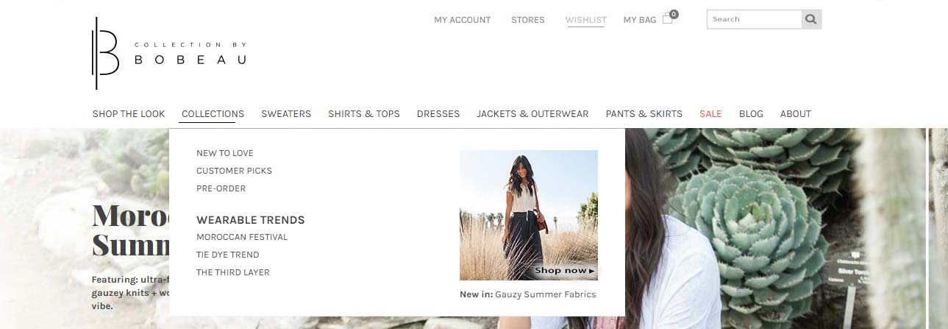

**Changes:**

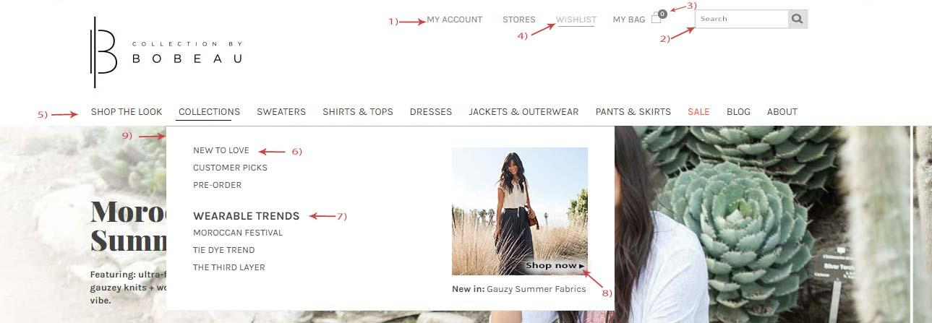

**Description of Changes:**

1. Top bar updated in uppercase.
2. ‘Search’ bar placed in the top bar with a magnifying glass icon.
3. ‘My bag’ updated to black color.
4. Menu hover color changes to grey.
5. Main menu font increased and changed to uppercase.
6. Flyout menu font size increased and changed to uppercase..
7. Wearable Trends- Font size increased.
8. ‘Shop Now’ button placed at the bottom for image visibility.
9. Flyout menu box resized.

## **Footer**

**Recommended:**

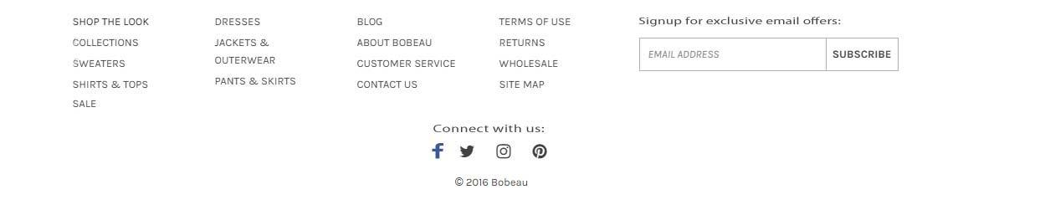

**Changes:**

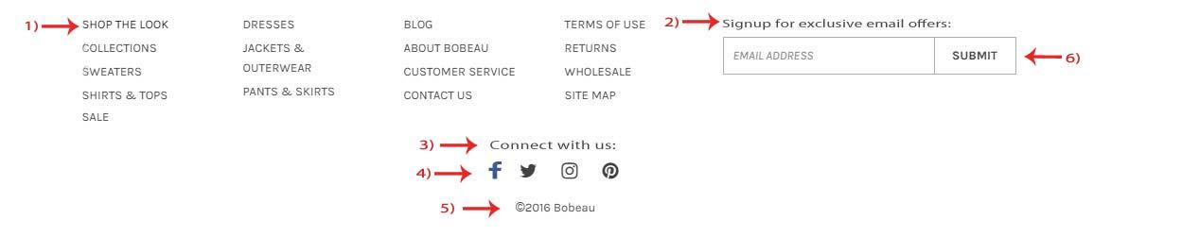

**Description of Changes:**

1. Font size increased and changed to uppercase
2. Font style changed to normal from italic
3. Social media icons center aligned.
4. Social icons color change, while mouse hover.
5. Copyright center aligned and fixed spacing.
6. ‘Submit’ button changed to ‘Subscribe’ and font color changed to black.

## **Homepage of the website**

**Recommended:**

**First half:**

**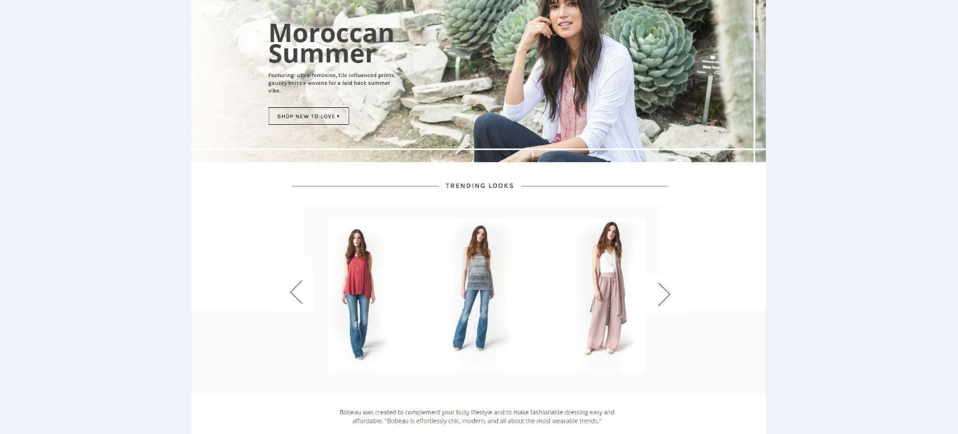**

**Changes:**

**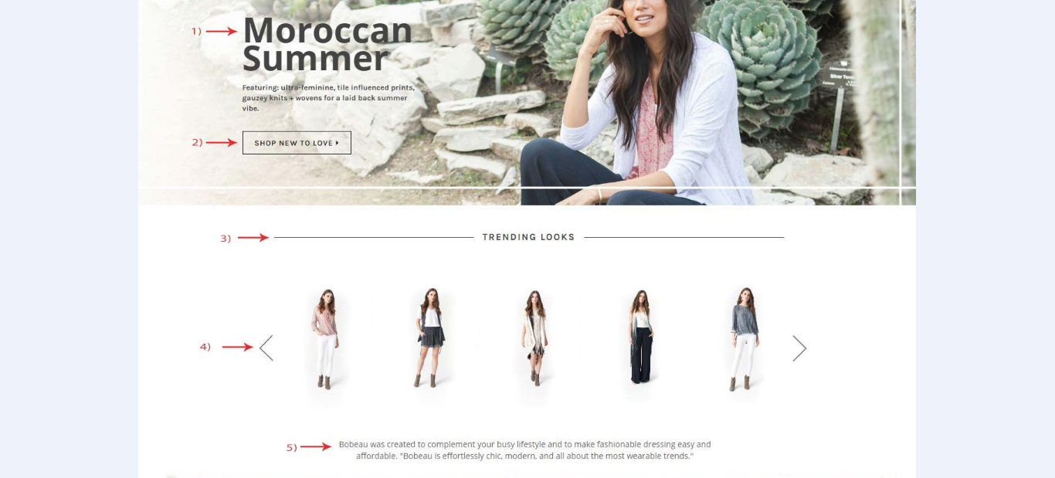**

**Description of Changes:**

1. Font style changed
2. Button color changed.
3. Title bar color changed.
4. Arrow changed and made the carousel images bigger
5. Updated the font from italic to normal

**Recommended**

**Second half of the page**

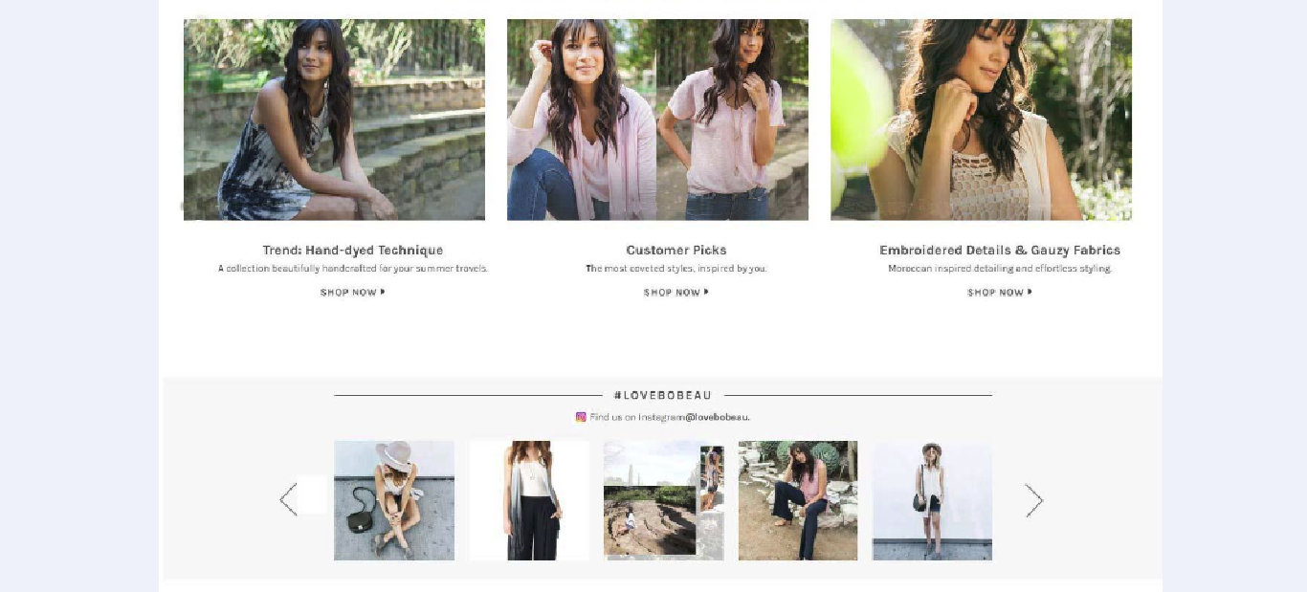

**Changes:**

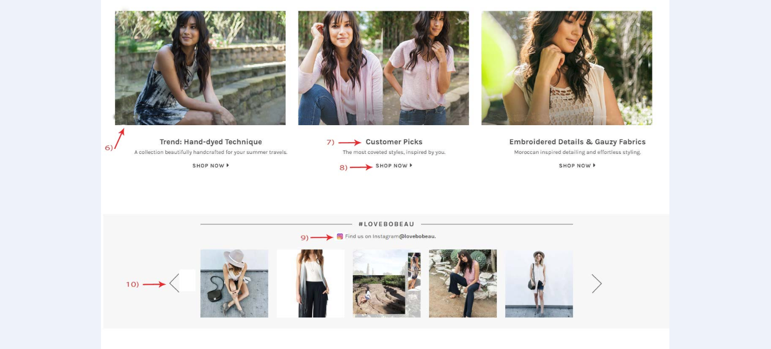

**Description of Changes:**

1. Text and line removed from the images
2. Font size increased and in bold.
3. Font size increased and in bold.
4. Placed new Instagram logo.
5. Arrows bigger in size and sharper.

## **Directory Page**

**Recommended:**

### C:\Users\kkataria\Desktop\Bobeau screenshot\Directory_recom_Page_1.png

**Changes :**

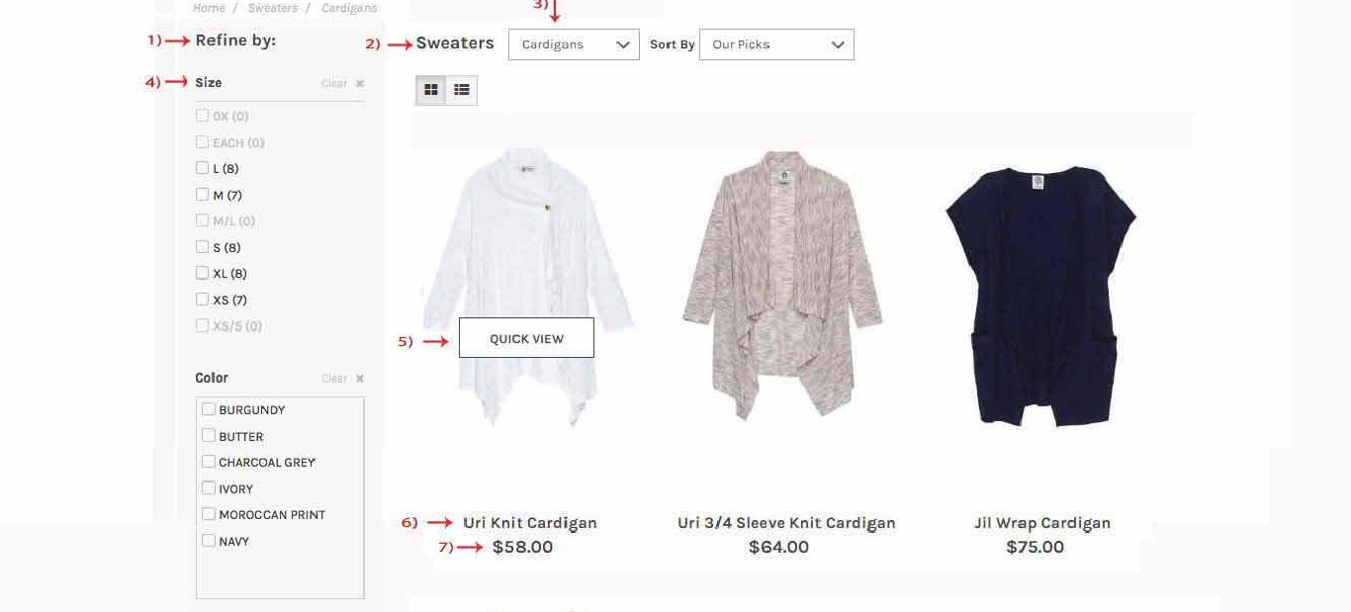

**Description of Changes:**

1. Font changed and aligned with the sweater title.
2. Font changed.
3. Font changed from italic to normal.
4. Sorting options increased.
5. ‘Quick view’ button color changed to black.
6. Font size increased and bolded.
7. Font size increased and bolded.

**Recommeded :**

**Second half -**

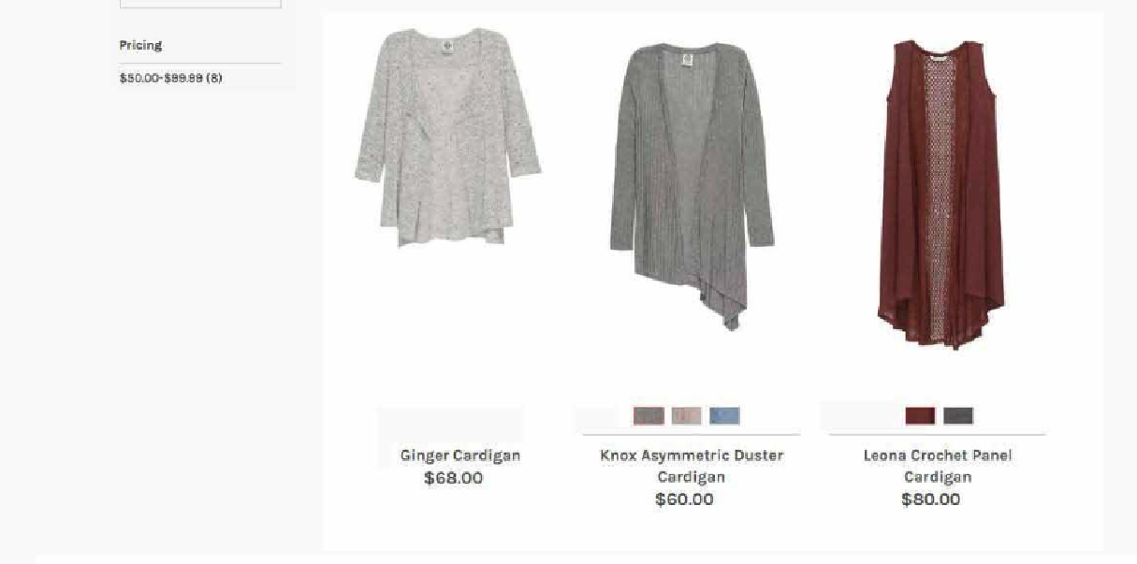

**Change :**

**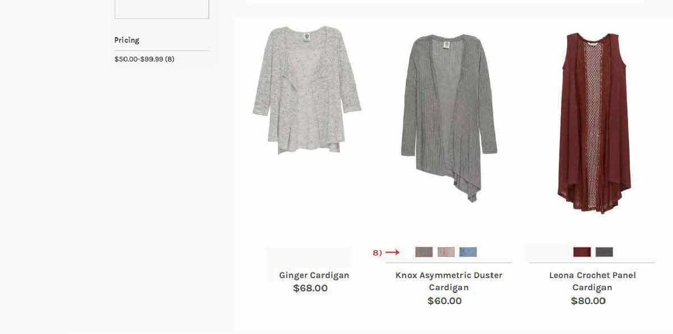**

**Description of Changes:**

1. Swaches – Centre aligned.

## **Product Page**

**Recommended:**

**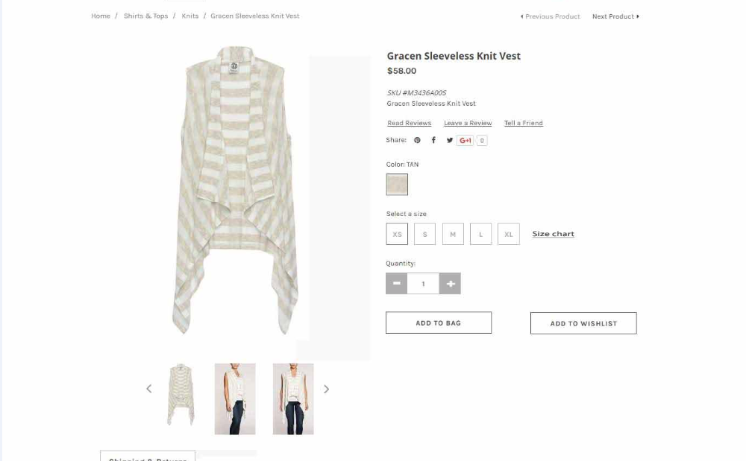**

**Changes:**

**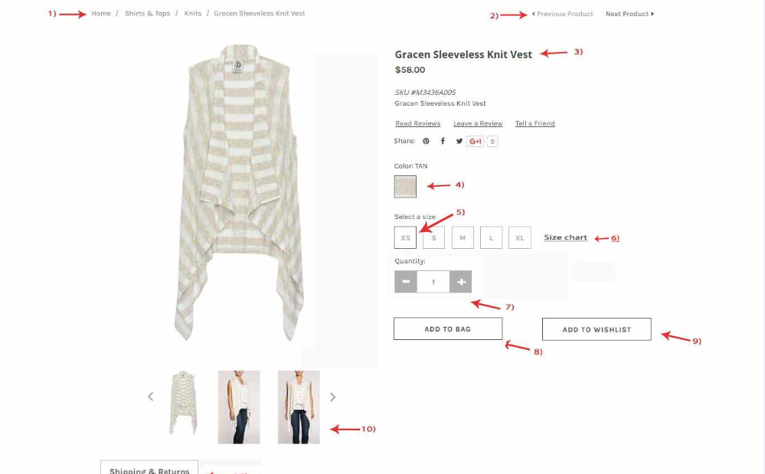**

**Description of Changes:**

1. Font changed from italic to normal
2. Font changed from italic to normal
3. Font Changed
4. Hover color changed to black
5. Hover color changed to black
6. Size chart button created. A popup opens with detailed size chart on clicking this button.
7. Quantity – Add and subtract button color changed to grey
8. ‘Add to Bag’ button color changed to black and now placed below Quantity.
9. ‘Add to Wishlist’ button changed to black and placed next to ‘Add to Bag’
10. Alternate images placed below the main image.

**Recommendation :**

**Second half**

**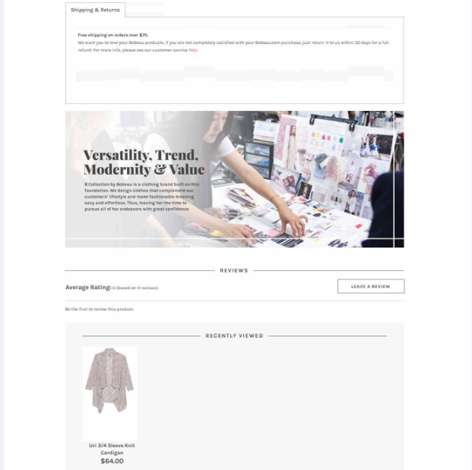**

**Changes :**

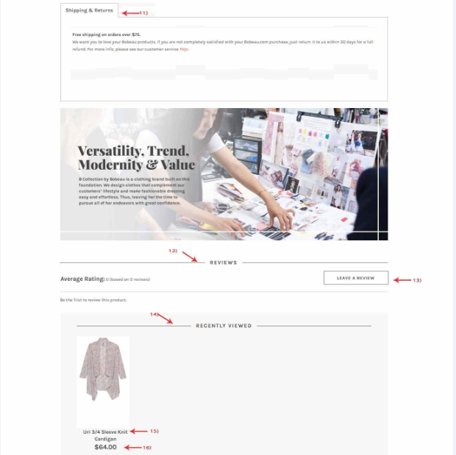

**Description of Changes:**

1. Size guide removed from the tab.
2. Color of review changed.
3. ‘Leave the review’ button color changed.
4. Color changed.
5. Font -size increased.
6. Size increased.

## 

## **Shooping Bag**

**Recommendation :**

**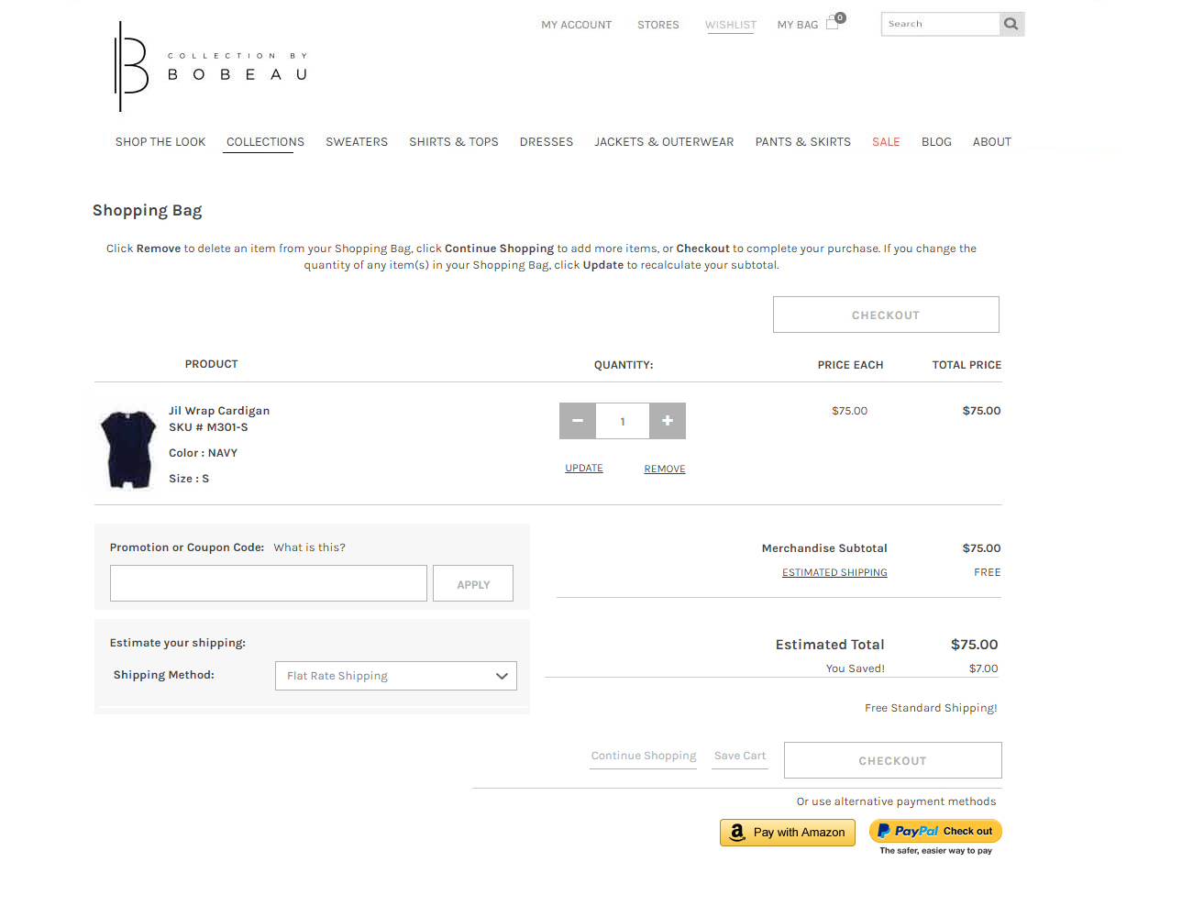**

**Changes**

**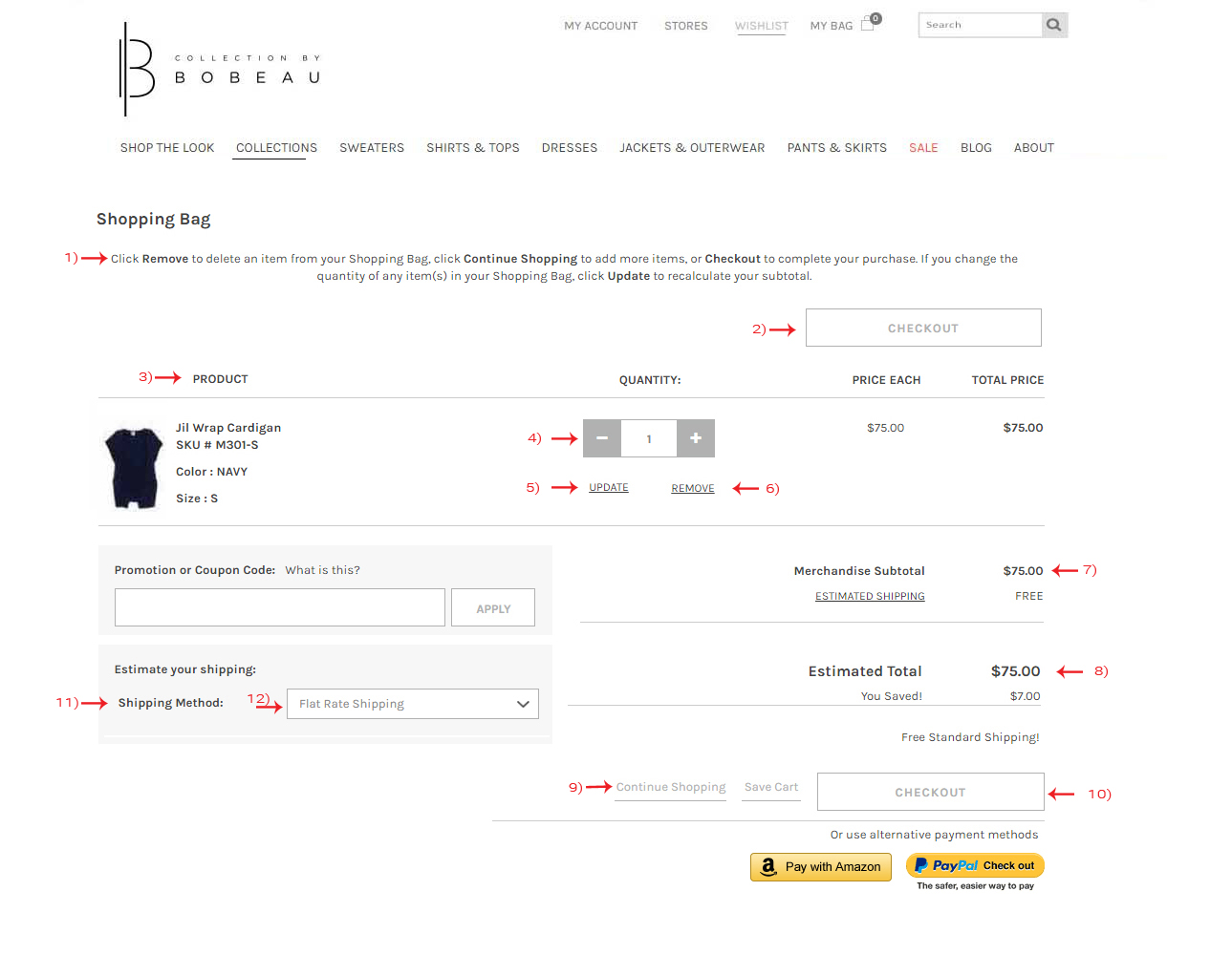**

### **Description of Changes**

1. Center aligned text and font size increased.
2. Updated the color of the button.
3. Changed font to uppercase and center aligned.
4. ‘Quantity’ increase and decrease button background changed to grey.
5. Text aligned.
6. Text aligned.
7. Font aligned.
8. Font aligned.
9. ‘Continue shopping’ and ‘Save Cart’ links aligned.
10. Button color changed.
11. Text aligned to left.
12. Text updated to normal form italic.

## **My Bag**

**Recommended:**

**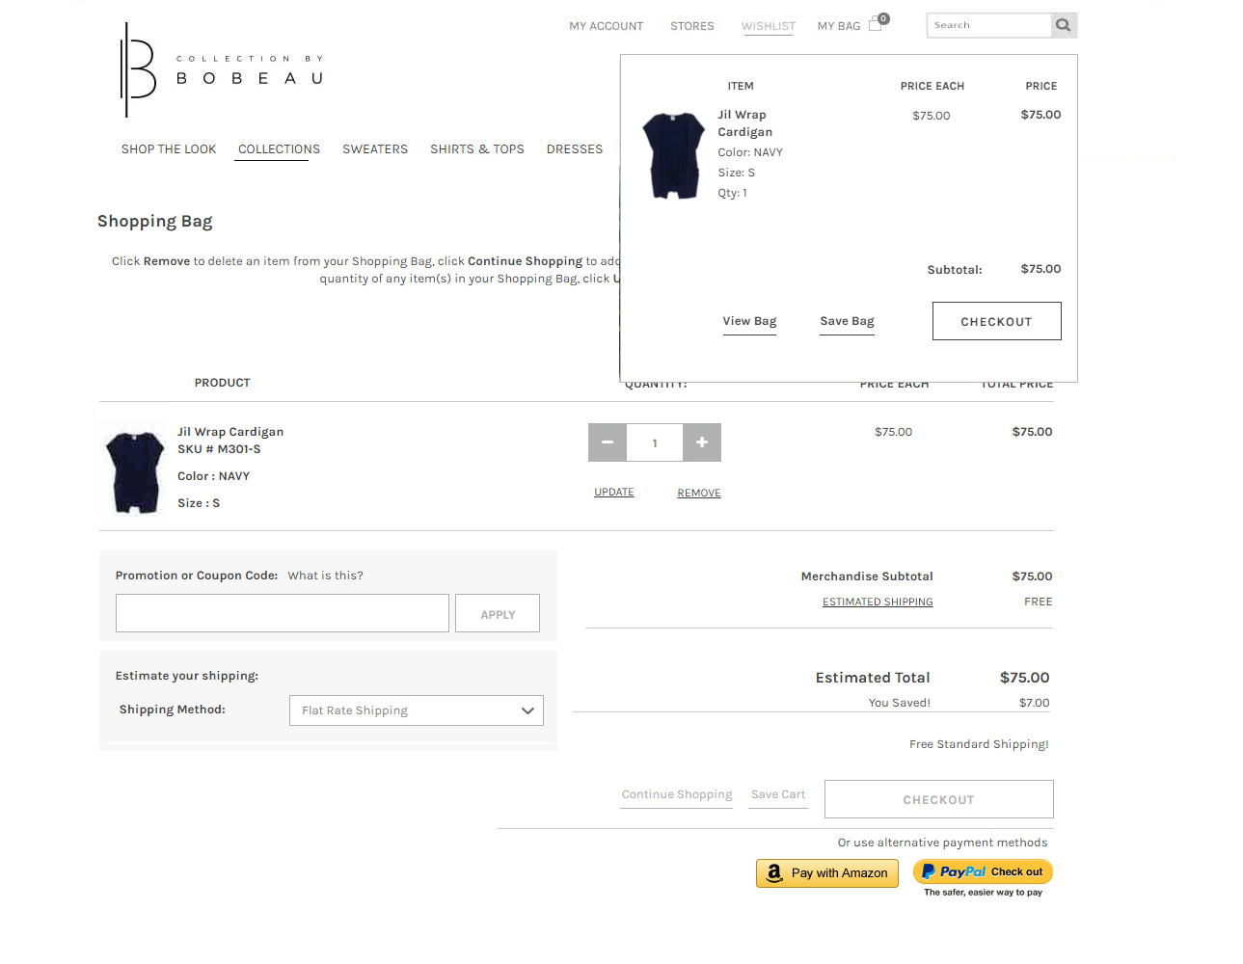**

**Changes**

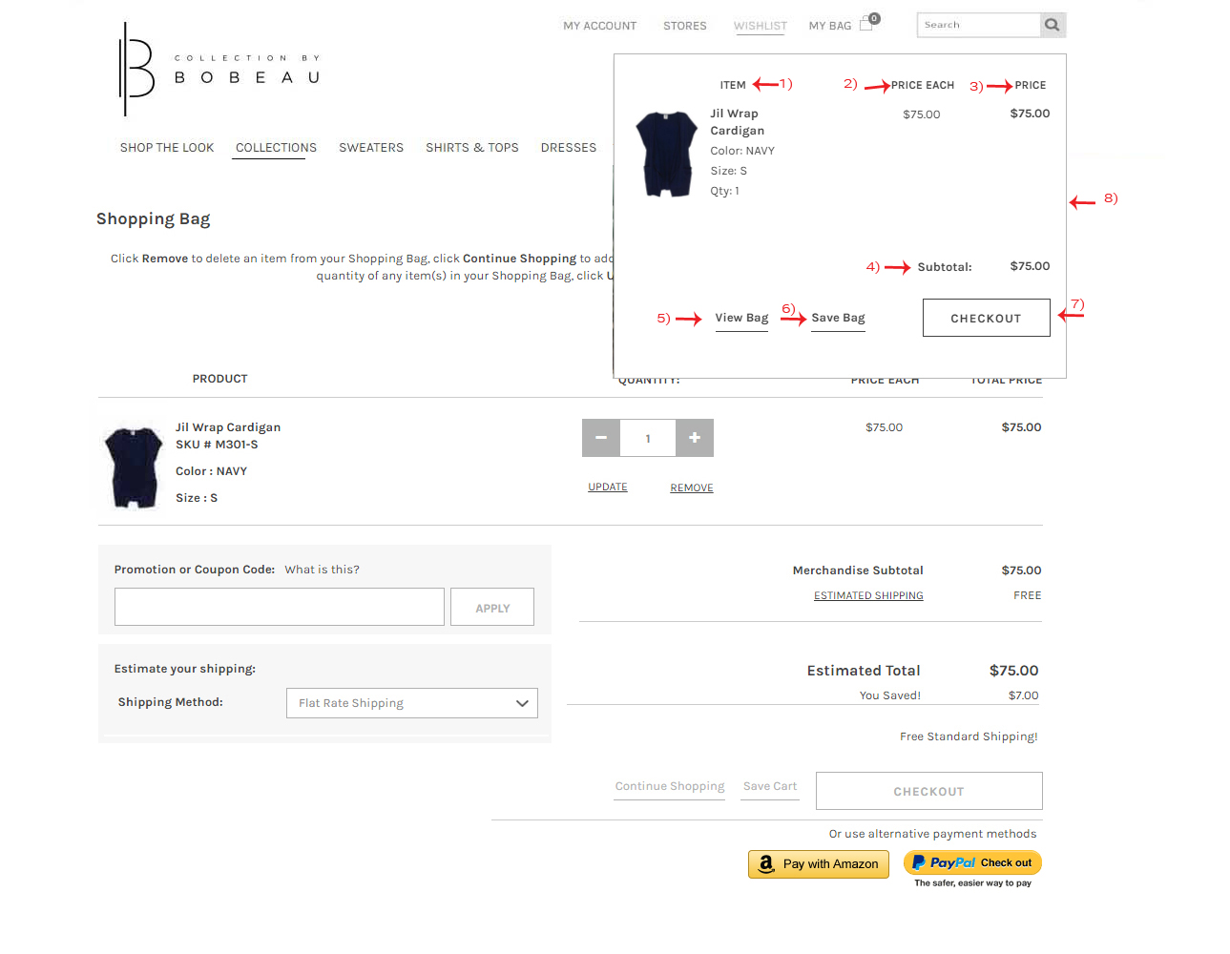

**Description of Changes**

1. Title aligned
2. Title aligned
3. Title aligned
4. Text aligned and font bolded
5. Link aligned
6. Link aligned
7. Button color changed
8. Border color added to box

## **Check-out Page**

**Recommended:**

### 

**Changes:**

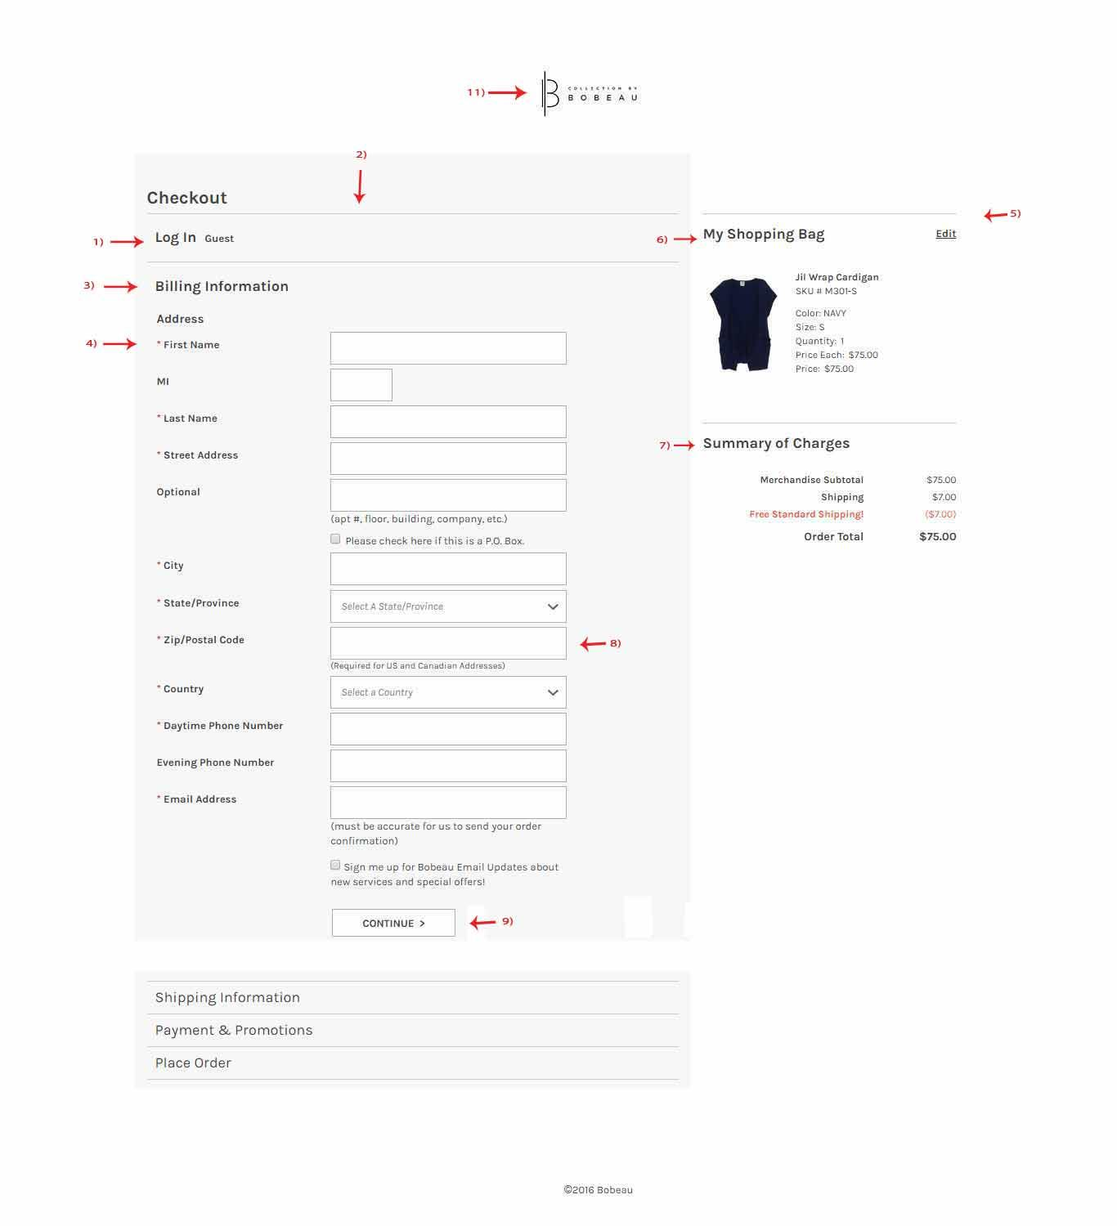

**Description of the Changes:**

1. Font bolded.
2. Aligned with the right box.
3. Font bolded.
4. Text aligned left.
5. My shopping bag - aligned left box.
6. Font bolded
7. Font bolded
8. Box width increased to full
9. Button color changed to grey
10. Copyright text center aligned
11. Logo center aligned

## **Billing Information Page**

**Recommended:**

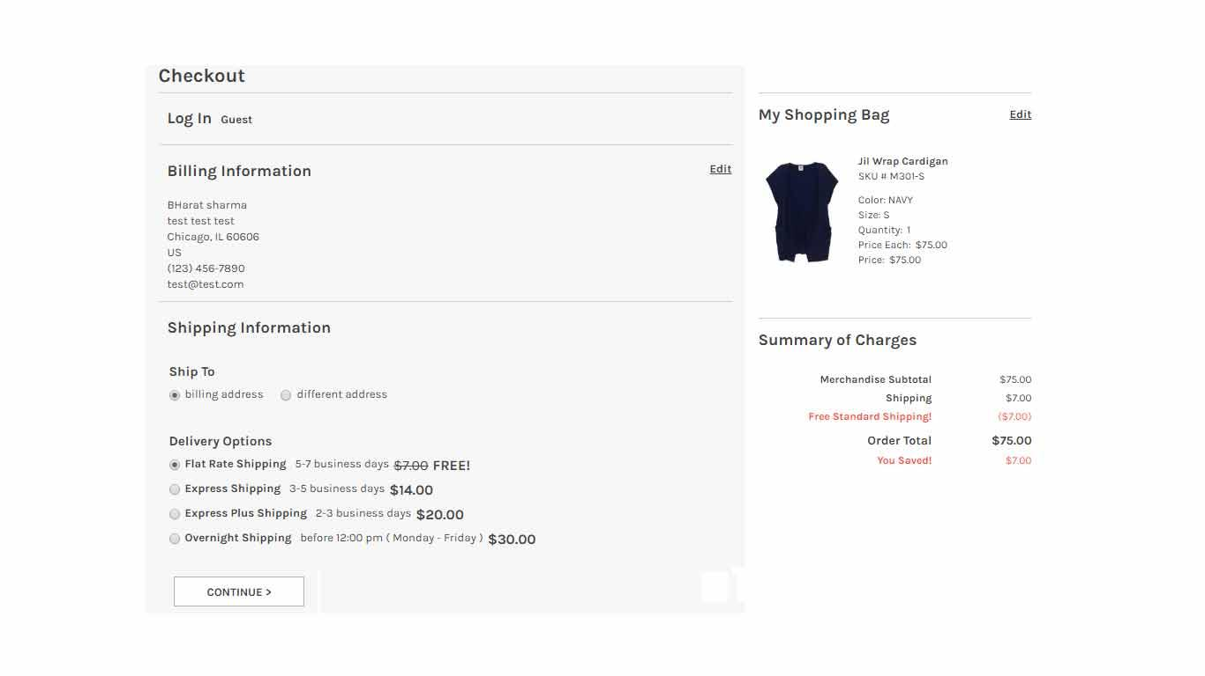

**Changes:**

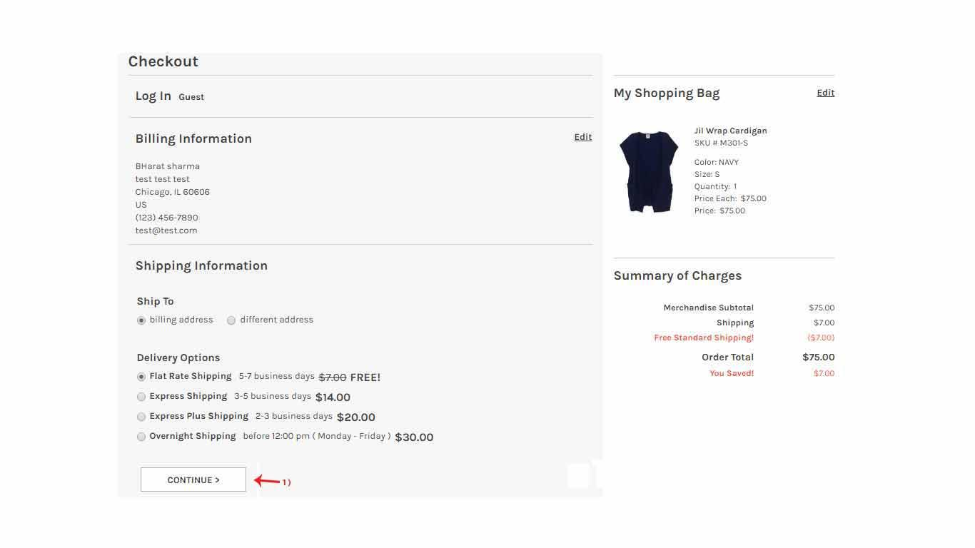

**Description of Changes:**

1. Updated button color and align to left.